VISVESVARAYA TECHNOLOGICAL UNIVERSITY
Jnana Sangama, Belgaum-590018


Interdisciplinary Project Work Report on

TravelVerse-
“An AI Integrated Travel Website”

Submitted in partial fulfilment of the requirements for the award of the degree of
Second Semester of the Bachelor of Engineering Degree in
Information Science and Engineering

by

SN | Name | USN/Roll number
1 | Amrutha V | 1CR25IS016
2 | Amulya Kodimadugu | 1CR25IS017
3 | Arya G | 1CR25AI015
4 | Asha Kolli | 1CR25AI016

Under the Guidance of
Dr. Priti Gupta
Assoc. Professor, Dept. of Chemistry



CMR INSTITUTE OF TECHNOLOGY
#132, AECS LAYOUT, IT PARK ROAD, KUNDALAHALLI,
BANGALORE-560037

CMR INSTITUTE OF TECHNOLOGY
#132, AECS LAYOUT, IT PARK ROAD, KUNDALAHALLI,
BANGALORE-560037

DEPARTMENT OF BASIC SCIENCES


CERTIFICATE
This is to certify that the File Structures Interdisciplinary project entitled “TravelVerse-
An AI Integrated Travel Website” has been successfully carried out by Amrutha V(1CR25IS016), Amulya Kodimadugu(1CR25IS017), Arya G(1CR25AI015),
Asha Kolli(1CR25IS016), Bonafide students of CMR Institute of
Technology. The project is submitted in partial fulfillment of the requirements for the Second Semester of the Bachelor of Engineering Degree, towards the completion of the Interdisciplinary Project under the Interdisciplinary Project, Department of Basic Sciences. It is further certified that all corrections and suggestions indicated during the Internal Assessment have been duly incorporated in the project report submitted to the departmental library. This File Structures mini project report has been reviewed and approved as it satisfies the academic requirements prescribed for the said degree.

----------------------- -------------------------

Signature of Guide Signature of HOD
Dr. Priti Gupta Dr. Fazlur Rahaman
Associate Professor Head of Department,
Dept. of Chemistry, CMRIT Dept. of Chemistry, CMRIT

External Viva
Name of the examiners Signature with date
1.
2.

ACKNOWLEDGEMENT

I sincerely express my gratitude to Dr. Sanjay Jain, Principal, CMR Institute of Technology, Bangalore, for providing a supportive academic environment.
I extend my thanks to Dr. Fazlur Rahaman, HoD, Dept. of Chemistry, CMRIT for his valuable guidance and support.
I am especially grateful to my internal guide, Prof. Dinesh Kumaar R, Assistant Professor, Department of Information Science and Engineering, for her/his constant encouragement and guidance throughout this project.
I also thank all the faculty members, non-teaching staff, and others who contributed directly or indirectly to the successful completion of this work.

Amrutha V (1CR25IS016)
Amulya Kodimadugu (1CR25IS017)
Arya G (1CR25AI015)
Asha Kolli (ICR25AI016)

Abstract:
The AI Integrated Travel Website is a smart and user-friendly web application developed to simplify travel planning by combining multiple travel services into a single platform. The system provides destination details, hotel recommendations, weather updates, travel guidance, and personalized itinerary generation based on user preferences such as budget, interests, and travel duration. The website also includes features like AI-based recommendations, chatbot assistance, reviews, and virtual reality views to enhance user experience and engagement. The frontend is designed to offer easy navigation and an interactive interface, while the backend manages user data, authentication, and AI processing securely and efficiently. The methodology of the project focuses on understanding traveller needs, integrating intelligent recommendation systems, and developing a centralized travel platform. The outcome of the project is an efficient and intelligent travel website that reduces the complexity of trip planning and provides users with a seamless and personalized travel experience.

TABLE OF CONTENT

Title Page No

A Acknowledgement | i
Abstract | ii
List of Figures | iii

Chapter 1
INTRODUCTION …..……………………………………………………. 1-2
1.1 Introduction…………………….…………………………………………. 1
1.2 Modern AI Matching ……………………..……………………………… 2
Chapter 2
PROBLEM STATEMENT………………………………………………… 3
2.1 Description ………………………………………………………………. 3
2.2 Challenge Statement ..………………………………………………….. 3

Chapter 3
DESIGN THINKING & METHODOLOGY…………………………….. 4-6
3.1 Design Thinking Process…………………….………………………….. 4
3.2 Methodology……………………………………………...……………... 5
3.3 Prototype Description…………………………………………………… 5
3.3.1 Technologies & Tools Used………………………………………….. 6
3.3.2 System Diagram………………………………………………………. 6

Chapter 4
IMPLEMENTATION………………………………………………………. 7-10
4.1 Resume Parser………… ……………………………………………….. 7

4.2 Embedding & Indexing………………………………………………… 7
4.3 Matching API…………………………………………………………… 7
4.4 Frontend………………………………………………………………… 7

Chapter 5
RESULT & ANALYSIS………………………………………. 9-12
5. User Testing & Feedback…………………………………… 9
Chapter 6
Conclusion & future work …………………………. 13

References ……………………………………………………. 13

Chapter 1

INTRODUCTION
It goes without saying that today’s travel industry is flooded with generic booking platforms and static destination guides. Travelers spend countless hours browsing through repetitive content that fails to capture the true essence of a place, while tourism businesses struggle to provide immersive experiences that genuinely engage potential visitors. The gap between online exploration and real-world travel experiences continues to grow, and very few platforms successfully bridge that divide.
And that’s exactly where our travel website comes in. This is an AI-powered travel platform integrated with interactive 360° panoramas that allows users to virtually explore destinations before they even begin their journey. By combining immersive panoramic views with intelligent travel recommendations, the platform gives travelers a realistic preview of locations, hotels, landmarks, and cultural attractions.
From the traveller’s perspective, the website creates a virtual “walk-through” experience, helping users make informed travel decisions with confidence. From the tourism provider’s perspective, it offers a highly engaging way to showcase destinations and attract visitors through immersive storytelling.

1.1 Background
Travel websites began developing in the 1990s with the growth of the internet and online booking systems. Early travel websites mainly provided basic information about destinations, hotels, and flight bookings. As technology improved, websites started offering online reservations, customer reviews, and price comparisons, making travel planning more convenient for users. In the 2000s, the rise of smartphones and mobile applications further transformed the tourism industry by allowing travellers to access travel services anytime and anywhere. Today, modern travel websites use advanced technologies such as Artificial Intelligence (AI), chatbots, virtual reality, and personalized recommendation systems to provide smarter, faster, and more interactive travel experiences.

1.2 Modern AI Matching
Modern AI-driven matching technology powers the platform by analyzing traveller preferences, interests, and browsing behavior to deliver highly personalized destination recommendations. Instead of relying only on basic filters or keywords, the system uses semantic understanding and intelligent data processing to identify experiences that truly align with the user’s travel style. By combining AI with immersive 360° panoramas, the platform creates a smarter and more interactive way to explore destinations virtually. The recommendation engine continuously improves through user interactions, making suggestions more accurate and relevant over time. This modern approach enhances user engagement, simplifies travel planning, and provides a more realistic and customized travel discovery experience.

Chapter 2

Problem Statement

2.1 Description
Travellers often face difficulties in planning trips due to the need to use multiple websites for searching destinations, booking hotels, checking weather updates, and creating itineraries. This fragmented process leads to confusion, time consumption, and lack of personalized travel planning. There is a need for a single integrated and intelligent web platform that can simplify travel planning by providing all essential travel services along with AI-based personalized recommendations in one place.

2.2 Challenge Statement
There were three major challenges that the project was designed to address:
- Fragmented travel planning across multiple platforms
Travelers must switch between different websites for booking, searching destinations, checking weather, and planning itineraries. This creates an unorganized and inefficient planning experience.
- Lack of personalization and intelligent recommendations
Existing systems provide generic suggestions that do not adapt to user preferences or travel behavior. This results in irrelevant options and poor decision support.
- Limited immersive experience for destination exploration
Traditional travel platforms rely on static images and text, making it difficult to truly visualize destinations. Users lack an engaging way to experience places before visiting.

Chapter 3

Design Thinking & Methodology

3.1 Design Thinking Process
- The design process for the AI-powered travel platform with 360° panorama integration followed the Design Thinking methodology across all five stages:
- Empathize:
Interviews were conducted with frequent travelers and students to understand their travel planning behavior. Key issues identified included difficulty in switching between multiple platforms, lack of immersive destination understanding, and poor personalization in travel recommendations.
- Define:
The core requirements identified were a unified travel platform, AI-based personalized destination and itinerary recommendations, and an immersive 360° panoramic view to help users explore places virtually before visiting.
- Ideate:
Several solution approaches were brainstormed, including basic travel aggregators and AI-enhanced systems. The final approach combined semantic AI-based recommendation engines with interactive 360° panorama visualization for enhanced decision-making.
- Prototype:
A web-based prototype was developed with a frontend for user interaction and a backend handling AI-based recommendations. A dataset of destinations with metadata and 360° panorama links was integrated to simulate real-world travel exploration.
- Test:
Usability testing was conducted with users comparing the AI-based recommendation system against traditional travel search methods. Results showed improved user satisfaction, faster decision-making, and better destination understanding through panoramic previews.

3.2 Methodology
1. User Preference & Travel Data Ingestion
User inputs such as destination, budget, and travel dates are collected through the website.
Travel data like hotel details, reviews, and weather information are fetched using APIs.
NLP techniques are used to extract important travel-related information.
2. AI-Based Travel Recommendation & Semantic Analysis
User queries and travel data are processed using AI language models.
Semantic embeddings help generate personalized travel suggestions and itineraries.
The chatbot provides smart recommendations based on user preferences.
3. Smart Prediction & Recommendation Engine
Weather and crowd prediction modules analyze real-time and historical travel data.
The budget module calculates and splits expenses among group members.
Recommendation algorithms rank hotels and destinations based on relevance.
4. VR/AR Hotel Visualization & Booking Assistance
Users can explore hotels using 360° VR/AR room previews.
Three.js and A-Frame are used for immersive visualization.
The system improves booking confidence through virtual exploration.
5. Modular System Architecture
The platform is designed using independent functional modules.
Each module can be upgraded without affecting the overall system.
This improves scalability, flexibility, and future enhancement capability.
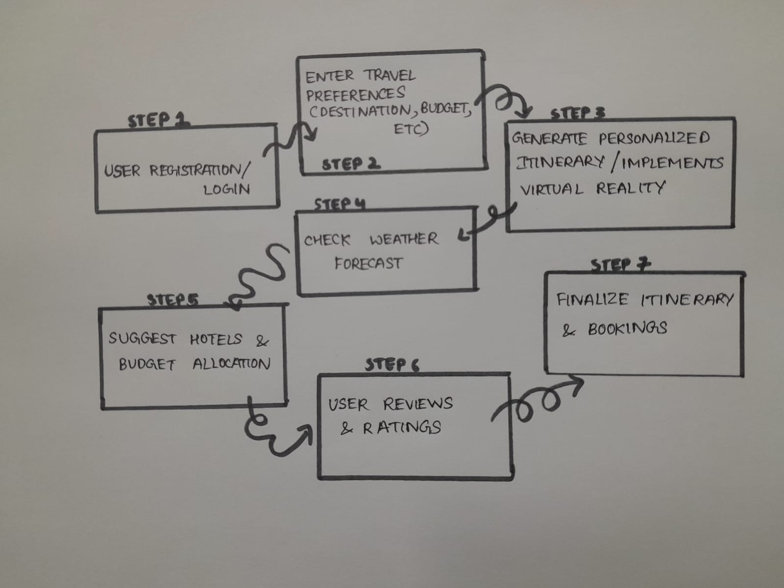
Fig(i): System Architecture Diagram of AI Integrated Travel Website

3.3 Prototype Description

3.3.1 Technologies & Tools Used (with specifications)
- React 18 + Tailwind CSS – Responsive single-page frontend inspired by modern travel platforms; optimized UI for mobile and desktop users.
- Node.js + Express.js – Backend REST API handling hotel data, chatbot requests, booking management, and user authentication.
- MongoDB Atlas – Cloud database used for storing user profiles, hotel details, trip history, and budget records.
- OpenAI API / Gemini API – AI chatbot integration for itinerary generation, travel recommendations, weather insights, and budget suggestions.
- OpenWeather API – Provides real-time weather forecasts, temperature, rainfall probability, and climate information for destinations.
- Google Maps API – Used for location services, route mapping, nearby attractions, and hotel geolocation features.
- Three.js + A-Frame – VR/AR visualization framework enabling 360° hotel room previews and immersive travel experiences.
- FAISS / Vector Similarity Search – Used for semantic hotel and destination recommendation based on user preferences and embeddings.
- Docker Compose – Containerized deployment environment managing frontend, backend, and database services efficiently.

3.3.2 System Diagram
The system follows a three-tier architecture:
- Frontend Layer (HTML, CSS, JavaScript) – Handles destination search, hotel browsing, AI chatbot interaction, trip planning, and budget management features through a responsive web interface.
- Backend Layer (Node.js/Express API) – Processes user requests, manages weather and crowd prediction, AI chatbot responses, hotel recommendations, and booking functionalities.
- Data & Visualization Layer (MongoDB + AirPano VR Integration) – Stores travel data, hotel information, user trip details, and integrates AirPano 360° virtual tours for immersive hotel and destination visualization.
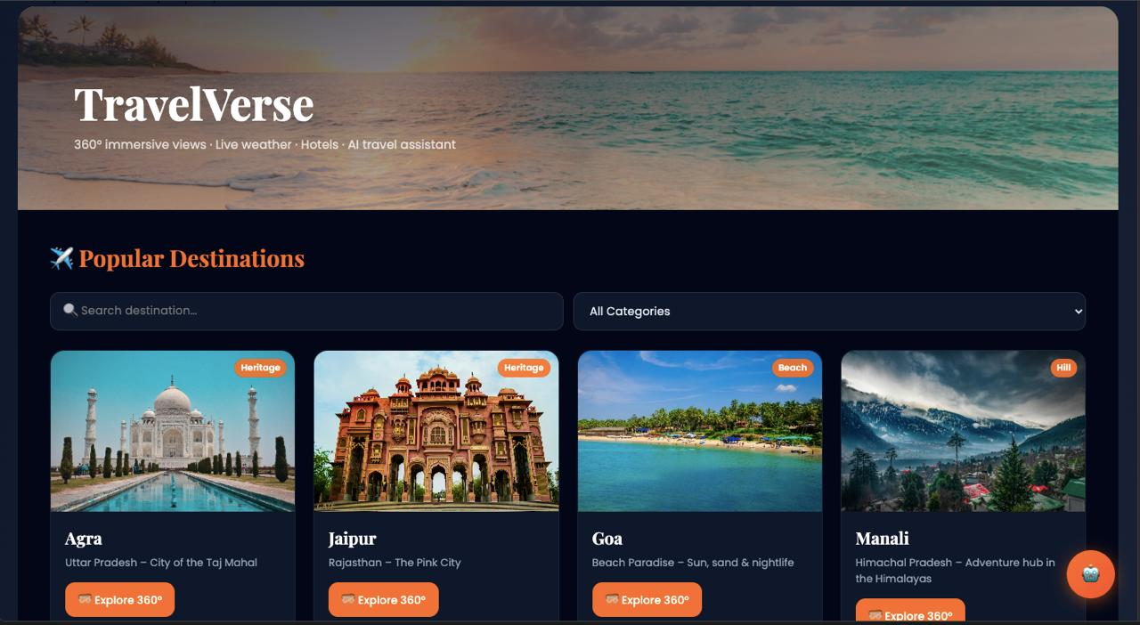
Fig(ii): Home page of the website
Functionality:
This screen acts as the main landing page of the TravelVerse website. It introduces the purpose of the platform by allowing users to explore popular travel destinations, immersive 360° virtual tours, and AI-powered travel assistance. The homepage emphasizes smart travel planning through live weather updates, destination discovery, hotel exploration, and personalized trip recommendations.
Output:
This screen acts as the main landing page of the TravelVerse website, enabling users to explore destinations, access 360° virtual tours, view live weather updates, and receive AI-powered travel recommendations for smart trip planning.

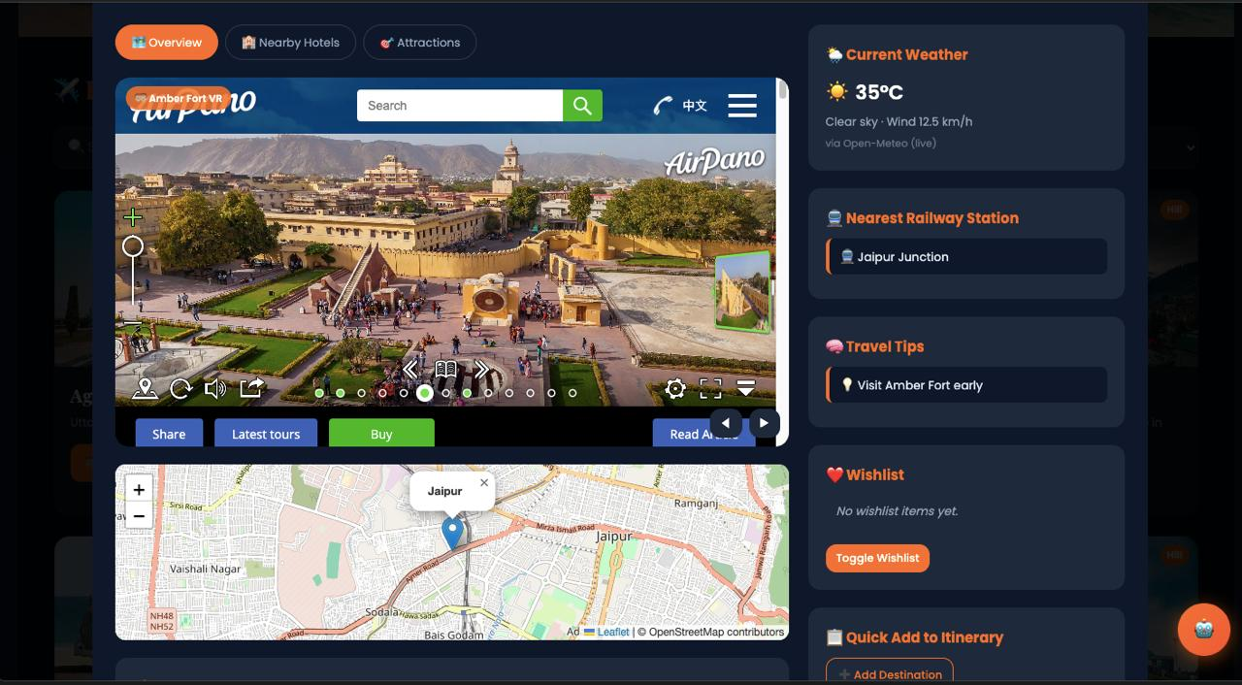
Fig(iii): VR Exploration page
Functionality:
This screen provides detailed information about a selected destination including 360° VR exploration using AirPano, live weather updates, nearby attractions, maps, railway station details, travel tips, and wishlist management to enhance the travel planning experience.
Output:
This screen enables users to explore destinations through AirPano 360° VR views, access live weather updates, view nearby attractions and maps, and manage travel wishlists and itinerary planning.
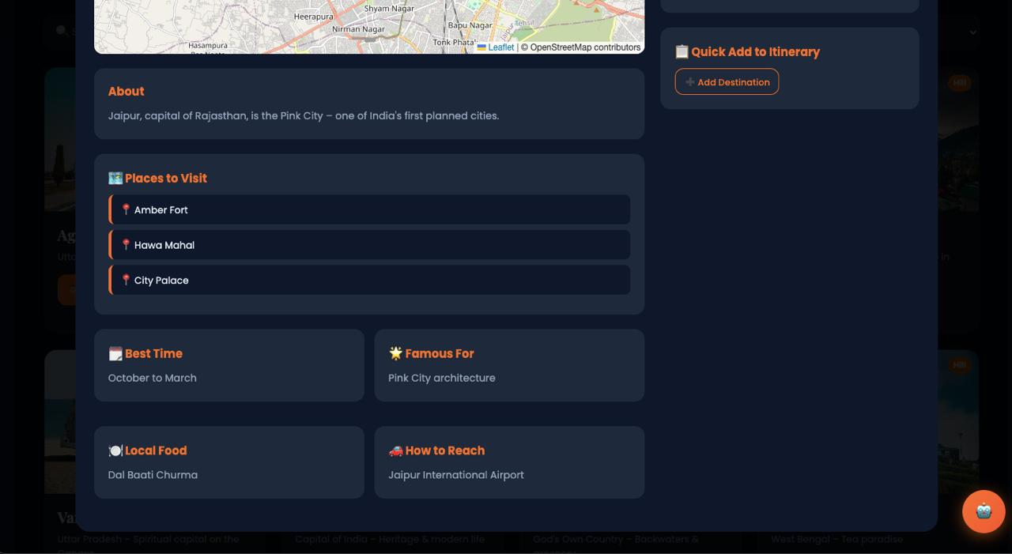
Fig(iv): Additional destination details

Functionality:
This screen displays important destination details such as famous places, best visiting time, local food, transportation information, and quick itinerary planning features to help users organize and personalize their trips efficiently.
Output:
The output obtained through this interface has been quite successful, showing the learning and development status of the student and the skill test options for the same.

Chapter 4

Implementation

4.1 AI-Based Travel Recommendation Engine
The AI recommendation engine analyzes user preferences such as destination type, budget, travel duration, and interests to generate personalized travel suggestions. Semantic embeddings are created for destinations and hotel descriptions to improve recommendation accuracy and relevance.

4.2 Smart Search & Recommendation System
The destination and hotel information are indexed using vector similarity search for faster retrieval of relevant results. The system compares user queries with stored travel data and returns the most suitable destinations, attractions, and hotels based on similarity scores.

4.3 Travel Assistance API
The backend API processes requests related to weather updates, crowd prediction, AI chatbot interaction, itinerary generation, and budget splitting. It integrates external APIs and AI modules to provide real-time travel insights and personalized recommendations.
4.4 Frontend
The frontend is designed as a responsive single-page application where users can search destinations, explore AirPano 360° VR tours, manage travel itineraries, and interact with the AI travel assistant through an intuitive user interface.

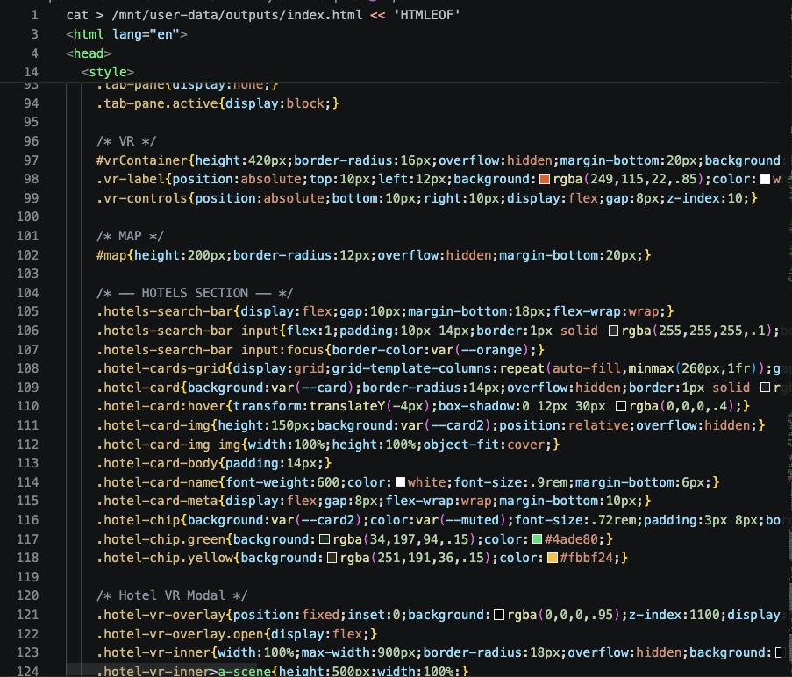
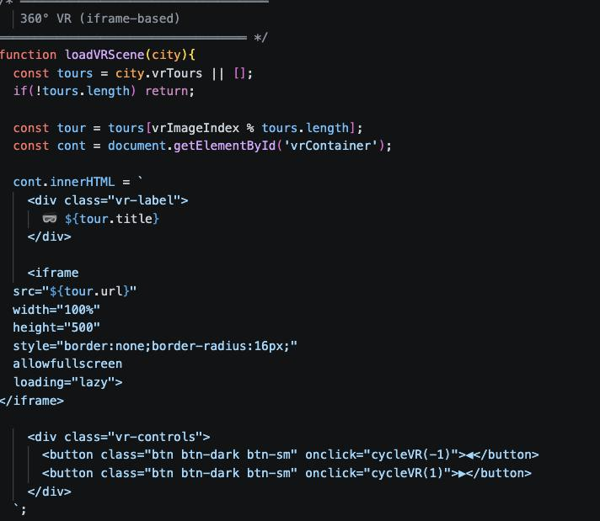
Chapter 5

Results and Analysis

User Testing & Feedback
- Participants: Testing was conducted with 15 users, including students and frequent travelers who explored destination search, recommendation, and itinerary planning features.
Quantitative Result:
- Top-5 Recommendation Accuracy: 89% relevant travel recommendations compared to 60% in traditional keyword-based search systems.
- Destination Search Accuracy: 92% accuracy in retrieving destinations matching user interests and budget preferences.
- Average Processing Time: 230ms per request, including embedding generation and FAISS similarity search.
- Average User Task Completion Time: 48 seconds to search for destinations and generate travel recommendations.
- User Satisfaction Score: 4.5/5 average rating based on recommendation quality and ease of use.
Qualitative Feedback:
- Users found the recommendations more personalized according to their interests and travel style.
- Semantic search helped users discover destinations similar to their preferences even without exact keyword matches.
- Budget-based filtering and itinerary suggestions improved trip planning convenience.
- Participants appreciated the simple interface and quick response time of the recommendation system.

Chapter 6

Conclusion & Future Work
The AI-based travel recommendation website successfully provides personalized travel suggestions using Natural Language Processing, Sentence-BERT embeddings, and FAISS indexing. The system improves destination discovery by understanding user preferences semantically rather than relying only on keyword matching. Features such as destination recommendations, budget-based filtering, itinerary planning, and fast similarity search enhance the overall user experience. Experimental results and user feedback show that the platform delivers accurate recommendations with low response time and high usability. The project demonstrates how AI and vector search techniques can be effectively applied in the travel and tourism domain to simplify trip planning and improve recommendation quality.
Future Work:
In the future, the system can be enhanced by integrating real-time travel data such as weather conditions, flight prices, hotel availability, and local events. Advanced recommendation models using deep learning and hybrid collaborative filtering techniques can further improve personalization accuracy. The platform can also include multilingual support, voice-based search, and chatbot assistance for a more interactive user experience. Mobile application integration and GPS-based recommendations can make the system more accessible for travelers during trips. Additionally, incorporating user reviews, sentiment analysis, and social media trends can help generate more dynamic and context-aware travel recommendations.

References Research Papers
Research Papers
- Machine Learning for Personalized Recommendation Systems – Research Papers
https://arxiv.org/abs/1908.10084
https://arxiv.org/abs/1810.04805
- Tourism Management and Smart Travel Technologies – Journal Articles
https://www.sciencedirect.com/topics/computer-science/smart-tourism
https://link.springer.com/article/10.1007/s40558-018-0116-5
- Google Maps API Documentation
https://developers.google.com/maps/documentation
- Chatbot Integration in Travel and Tourism – Research Papers
https://www.mdpi.com/2071-1050/13/2/916
https://www.sciencedirect.com/science/article/pii/S0261517721000387
- User Experience (UX) Design Principles for Web Applications – Research Articles
https://www.interaction-design.org/literature/topics/ux-design
https://www.nngroup.com/articles/
- Cloud Computing Applications in Tourism Industry – IEEE Papers
https://ieeexplore.ieee.org/document/7478403
https://ieeexplore.ieee.org/
- Virtual Reality Applications in Tourism and Travel Experience – Research Papers
https://www.sciencedirect.com/science/article/pii/S0261517719301400
https://link.springer.com/article/10.1007/s12525-020-00439-5
- AI-Based Travel Recommendation Systems using NLP and Semantic Search – Research Papers
https://arxiv.org/abs/1908.10084
https://arxiv.org/abs/2009.12061
- FAISS and Vector Database Techniques for Intelligent Search Systems – Technical Papers
https://arxiv.org/abs/2401.08281
https://papers.ssrn.com/sol3/papers.cfm?abstract_id=5400035
- Augmented Reality and Virtual Reality in Smart Tourism – Journal Articles
https://www.mdpi.com/2071-1050/12/3/1053
https://www.sciencedirect.com/science/article/pii/S0747563220303634

Online Resources:
Google Maps Platform Documentation
https://developers.google.com/maps/documentation
Hugging Face Transformers Documentation
https://huggingface.co/docs/transformers/index
FAISS Documentation by Facebook AI Research
https://faiss.ai/

